Katalon Studio

1. **How to email results in katalon studio.**

**🡪How to configure email settings.**

**🡪Test Email notification.**

* Configure email settings.

Project > settings > email

Step – 1: Add,

Host: smtp.gmail.com

Port: 465

Username: [parthasaradhireddy4444@gmail.com](mailto:parthasaradhireddy4444@gmail.com) (email id of the sender)

Password: Password of the sending email.

Protocol: Select “TLS” or “SSL”.

Encrypt authentication data: Yes.

Username as sender: Yes.

Recipients: Receiving email id.

Include report as email attachment: Yes.

Enable to send email reports for both Test suite executions and Test suite collection executions: Yes.

Send Test Email: Yes.

If it throws an error like this,

🡪Go to Gmail settings, click on security and search for “Allow less secure apps” and click on ‘ON’.

🡪Click on ‘Test Connection’.

* Test Email Notification.

🡪Click on any one of the ‘Test Suite’ and click on execution information.

🡪Click on ‘Add’ and enter the recipient email address and save.

🡪Add the test cases to run and click on ‘Run’.

🡪All the test test cases should pass and it geneate a report and send to the recipient email.

1. **How to run katalon studio from command line.**

**🡪Why is command mode important.**

**🡪How to do console mode execution.**

**🡪Advantages.**

* Importance os command line execution.

🡪It is very easy to integrate with other systems like Continuous Integration (CI).

🡪Rus faster.

🡪No dependency on UI.

🡪Important for implementing at enterprie level.

* How to do console mode execution.

Note: Java should be installed on your system.

Step – 1: Click on ‘Build CMD’.



Step – 2: Add Test suite and select the particular browser to run and click on ‘Generate Command’.

Step – 3: Copy the text and open command prompt.

Step – 4: 

Step – 5: Paste the text and click on enter.



Step - 6: Katalon studio runs on the command mode.

* Advantages

🡪Faster runs.

🡪Auto schedule.

🡪Parallel executions.

🡪Integration with otherprocesses.

🡪No need to open GUI.

🡪Configure parameters: command | properties file.

1. **Kalatalon automation recorder. How to create automation tests faster.**

Features of katalon automation recorder:

🡪Powerful IDE to ecord and run web UI tests.

🡪Can edit your recorded tests.

🡪Can export tests in java, c#, Ruby, Python and Groovy.

🡪Plugin available on chrome and firefox (coming soon).

🡪Uses selenium 3 core engine.

How to install katalon recorder plugin on chrome:

Step -1: Search ‘chrome web store’ on google and click on it.

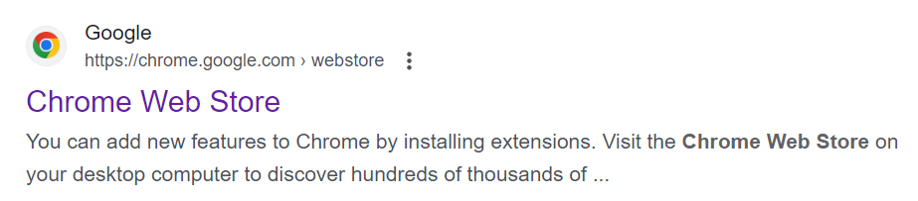

Step – 2: Search ‘katalon automation recorder’ and click enter.

Step – 3: Now you will see the picture like this.

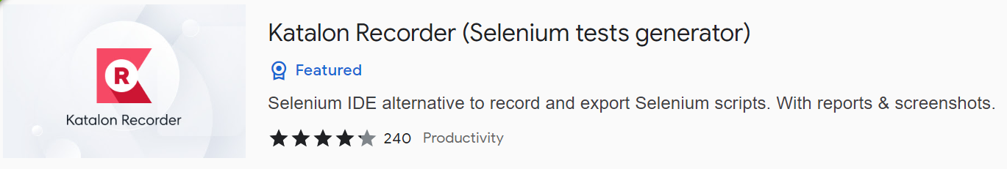

Step – 4: Open it and click ‘Add extension’ to the chrome.

Step – 5: Now open it under extensions folder on the right side of the screen.

Now you will see the,

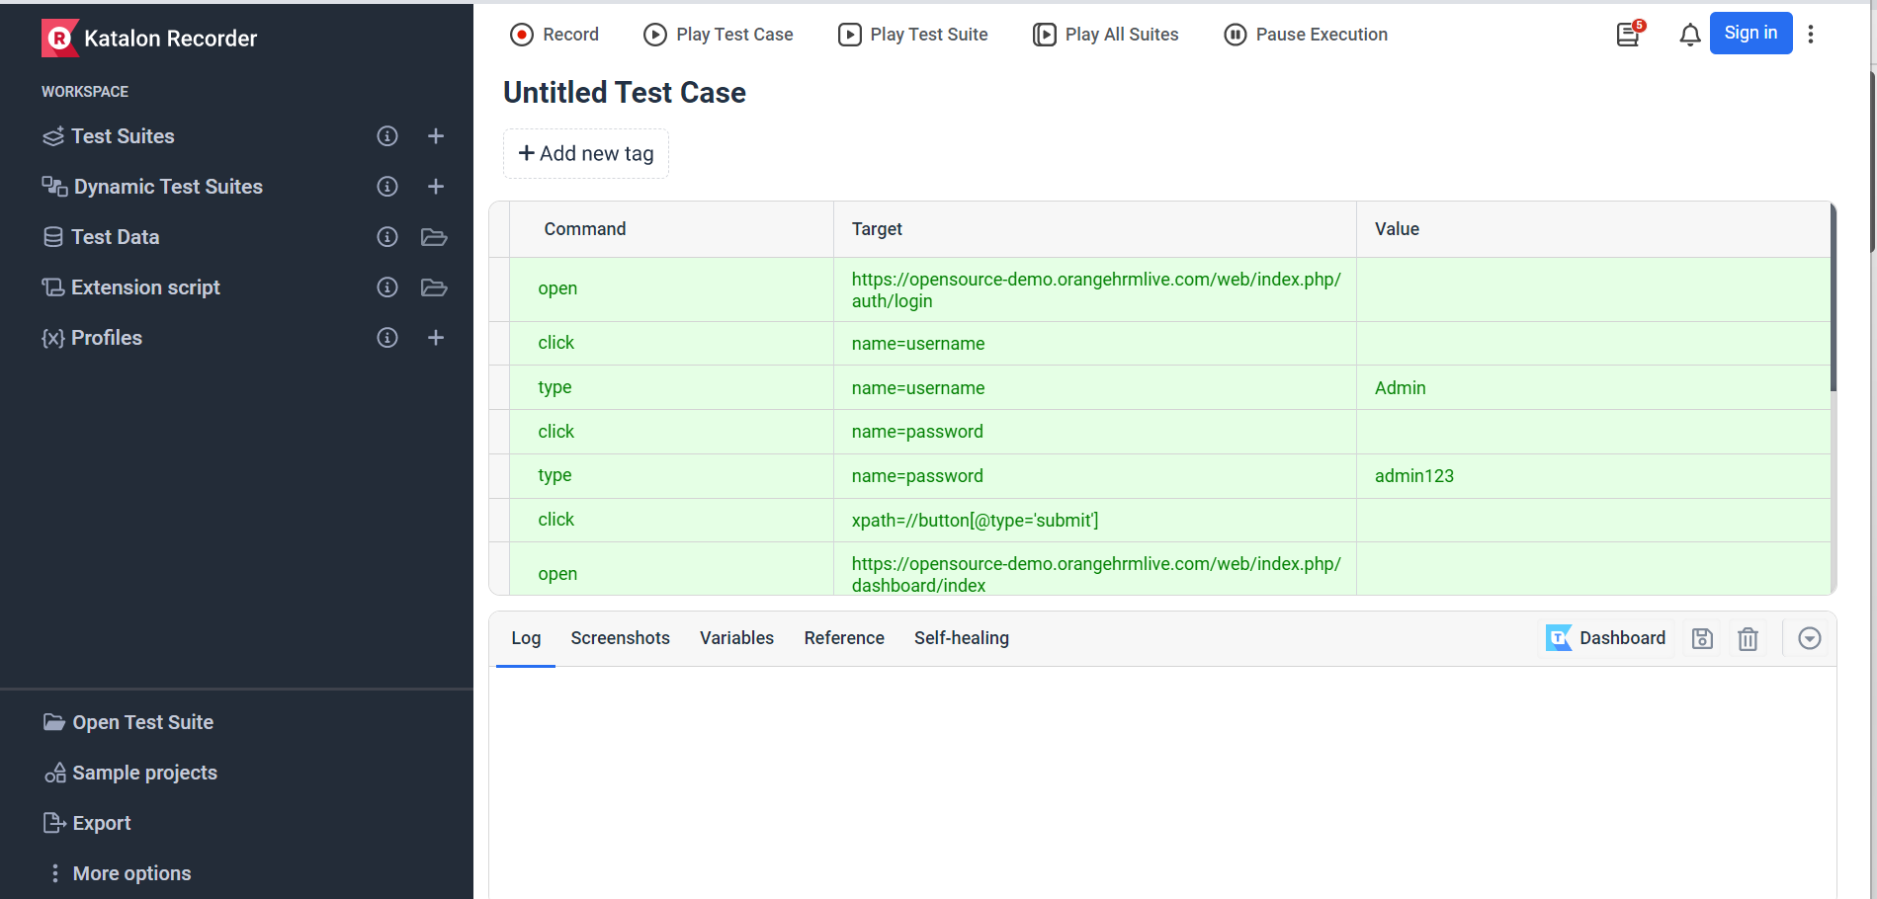

How to record a test case:

Step – 1: Click on record in the ‘katalon recorder’ and continue testing the UI in the chrome (while testing the UI in the chrome it automatically adds the steps in the recorder).

Step- 2: Now you can play the test case also.

Uses of export in katalon recorder:

Export makes to download .java file in the system and we can copy the file and paste it the eclipse to run in the framework.

Steps – 1: Select the framework and test case and click on export.

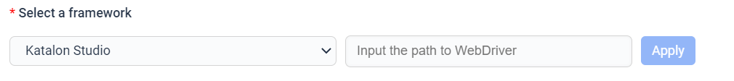

Step – 2: Now zip file will be downloaded and extract it and and paste it in the eclipse.

1. **How todo mobile testing on windows with katalon studio.**

🡪How to install Node .js

🡪How to install appium

🡪How to setup android device for automation.

🡪Connection and validation.

🡪Run test case on mobile

* How to install Node.js

Step – 1: Check if node.js is already intsalled in your system using the commands in the command prompt.

node -v or node –version

npm -v or npm –version

Step – 2: otherwise, download the node.js using <https://nodejs.org/en>.

* How to install Appium

Download Appium using the website <https://appium.io/>.

Check if java is already installed in your system using the commands in the command prompt.

java -version

where java

javac